Social Network Analysis

# Assignment No.2

## Ali Nauman – 18L1863

**Number of nodes in SCC, IN, OUT, TENDRILS+TUBES, and DISCONNECTED regions of Epinions network.**

**Strongly Connected Nodes:** 32223  
**Initial Out Nodes:** 47676  
**Out Nodes after deleting SCC Nodes:** 15453  
**Initial In Nodes:** 56459  
**In Nodes after deleting SCC Nodes:** 24236  
**In Tendril - Nodes:** 1  
**Out Tendril - Nodes:** 1  
**Nodes in Tube:** 0  
**All the Disconnected Nodes:** 3967

**Graph of number of pairs Vs. fraction of reachable nodes**

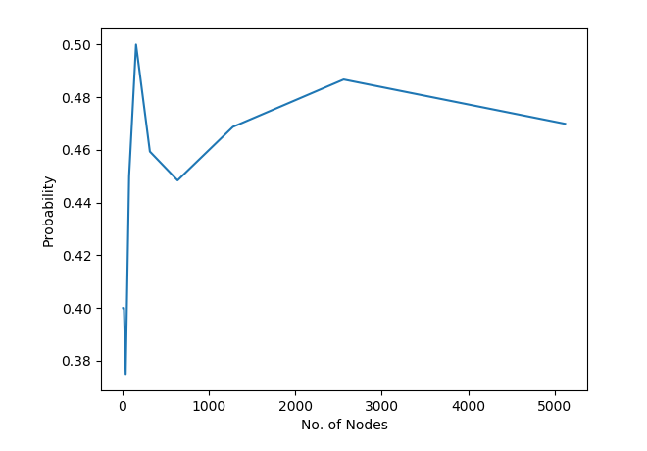

**What is your answer to probability of path existence when a pair of nodes is selected uniformly at random based on your experiment?**

While conducting the experiment on almost 10 iterations, given that every time the number of pairs increases by twice the number, starting from k = 10. It was almost run over ‘5120’ node pairs. We can see from the graph above that the value starts off with approximately, ‘0.4’ and continues to increase with the highest value of probability achieved for ‘160’ node pairs.

However, soon afterwards it starts to converge to a more stable value of around ‘0.46’ as the number of node pairs increases.

([10, 20, 40, 80, 160, 320, 640, 1280, 2560, 5120],

[0.4, 0.4, 0.375, 0.45, 0.5, 0.459375, 0.4484375, 0.46875, 0.48671875, 0.469921875])

Thus, it can be concluded the probability for path existence when a pair of nodes is selected uniformly at random is ‘0.469’.

**Top 10 ranked nodes along with their ranks in Epinions network when β = 0.8 and ϵ = 0.001**

([75887, 75886, 75885, 75884, 75883, 75882, 75881, 75880, 75879, 75878],

[0.0038842600451454165, 0.0019710715488781027, 0.0017669107231066032, 0.0015959300631559514, 0.0015420553802211502, 0.0015388688265045994, 0.0014843097516130574, 0.0013553040553419358, 0.0013118604972233666, 0.0012598715058006048])

**Also state the following for each of the top 10 ranked nodes in the network. Let x be the node:**

* **Number of incoming edges (indegree of x)**
* **Ranks of all the source pages having hyperlinks toward x**

([75887, 75886, 75885, 75884, 75883, 75882, 75881, 75880, 75879, 75878], 75872, 1, (4.568677323985117e-05, 4))

([75887, 75886, 75885, 75884, 75883, 75882, 75881, 75880, 75879, 75878], 75872, 1, (4.568677323985117e-05, 4))

([75887, 75886, 75885, 75884, 75883, 75882, 75881, 75880, 75879, 75878], 75872, 1, (4.568677323985117e-05, 4))

([75887, 75886, 75885, 75884, 75883, 75882, 75881, 75880, 75879, 75878], 75871, 1, (2.1972642488607573e-05, 5))